Statement that is correct

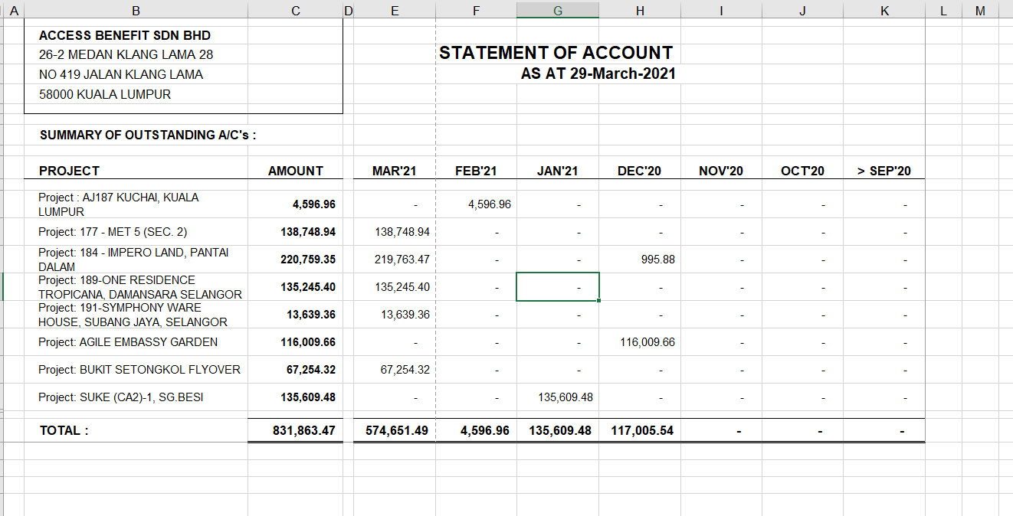

Generated by dotnet

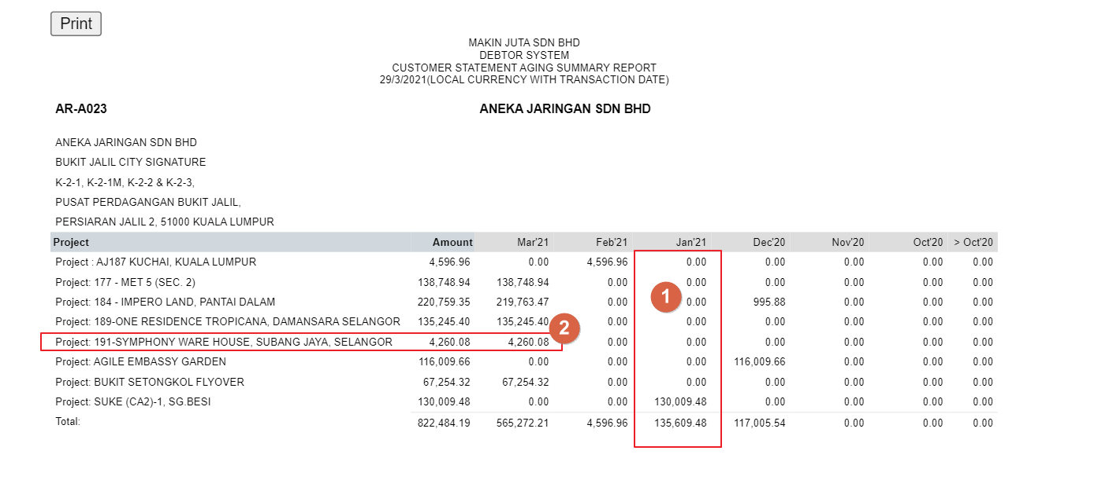

1. Jan’21 amount didn’t capture invoice number 1005707 but the total amount is correct

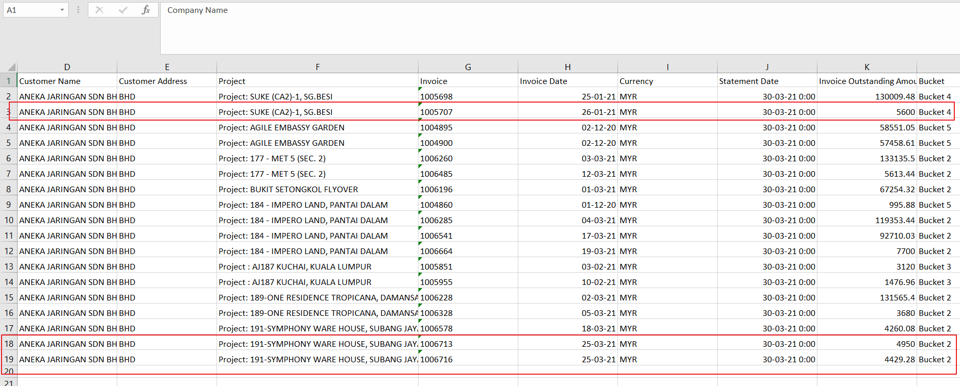

1. Project symphony ware house didn’t capture invoice 1006713 and 1006716 in the dotnet system